Sam Sample - 2026
Positions:
Defender, Midfielder
Team Name: Rio Rapids ECNL 08
Club colors: Burgundy and white
PERSONAL
Height: 5”7” Weight: 130 lb.
Address: 5555 Street Address NE
Albuquerque, NM 87122
Email: playeremail@gmail.com
Cell: 505-555-5555 Home: 505-555-5555
Parents: Dad’s Name, Mom’s Name
Your High School
ACADEMICS
Albuquerque, NM 87122

Date of Graduation: 2026
GPA: x.x /4.0 Class Rank: xx/yyy
SAT Score: Taking June 2022 or score
ACT Score: To be scheduled or score
PSAT Score: if SAT and ACT not available

Honors/AP Classes

Academic Accomplishments and Awards
(Reverse Chronological/Most Prestigious)

Academic Programs of Interest: Education, Engineering
Name, Role (club team coach)
REFERENCES
505-555-5555 reference@msn.com
Name, Role (high school coach)
505-555-5555 reference@gmail.com

Name, Role (other coach)
505-555-5555 reference@gmail.com

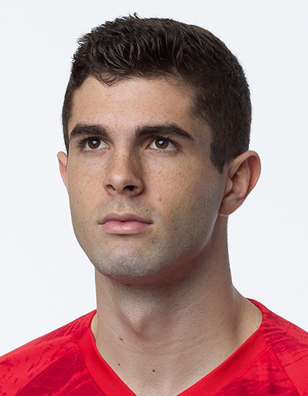

Club Team - Rio Rapids 08 GA (#10):
soccer
2020-Present
2023 GA Conference Champion
2023 Las Vegas Players Showcase
2022 ECNL Playoffs
2022 NM State Cup Champion

Your High School (#7):
Varsity: 2023 & 2022 JV: 2020
Team and Individual Accomplishments (Reverse Chronological/Most Prestigious)

MLS NEXT/ECNL/ODP/id2:
2022-23 Colorado Rapids MLS Next Event
2022-23 ECNL Discovery Player
2022-Present NM ODP Team
2021-23 Varsity Track:
Other Sports
200 meters & 4 x 400 relay
clubs / volunteering
Volunteer or Community Service Activities

Other Activities and Leadership Roles

Unique Personal Interests or Hobbies

